**Testing results of #384 Awarded tender with valid bid validity should be displayed under list of bid validity extension sub-menu**

1. Tenders with status of Completed awarded **(Fixed)**

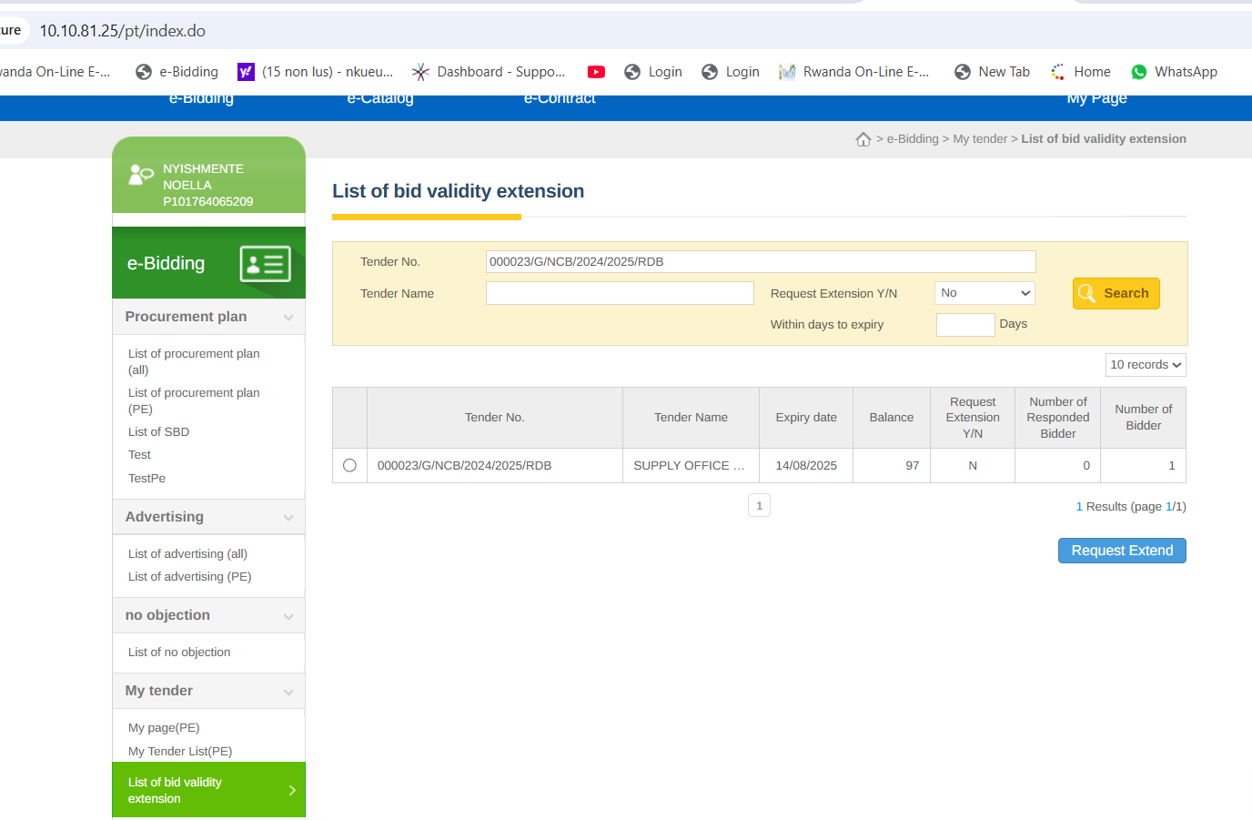

1. Tenders with status of Contract awarded **(Fixed)**

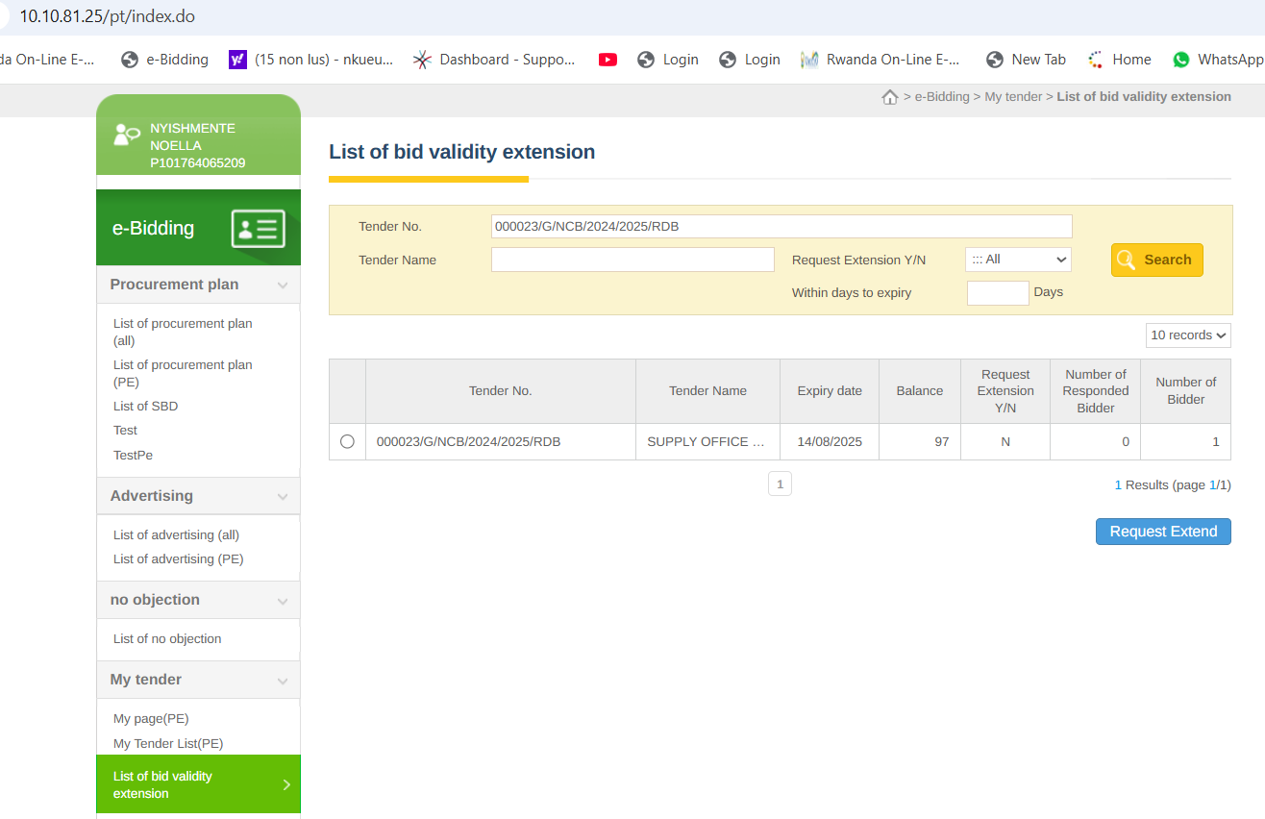

1. Tenders with staus of To evaluate **(Fixed)**

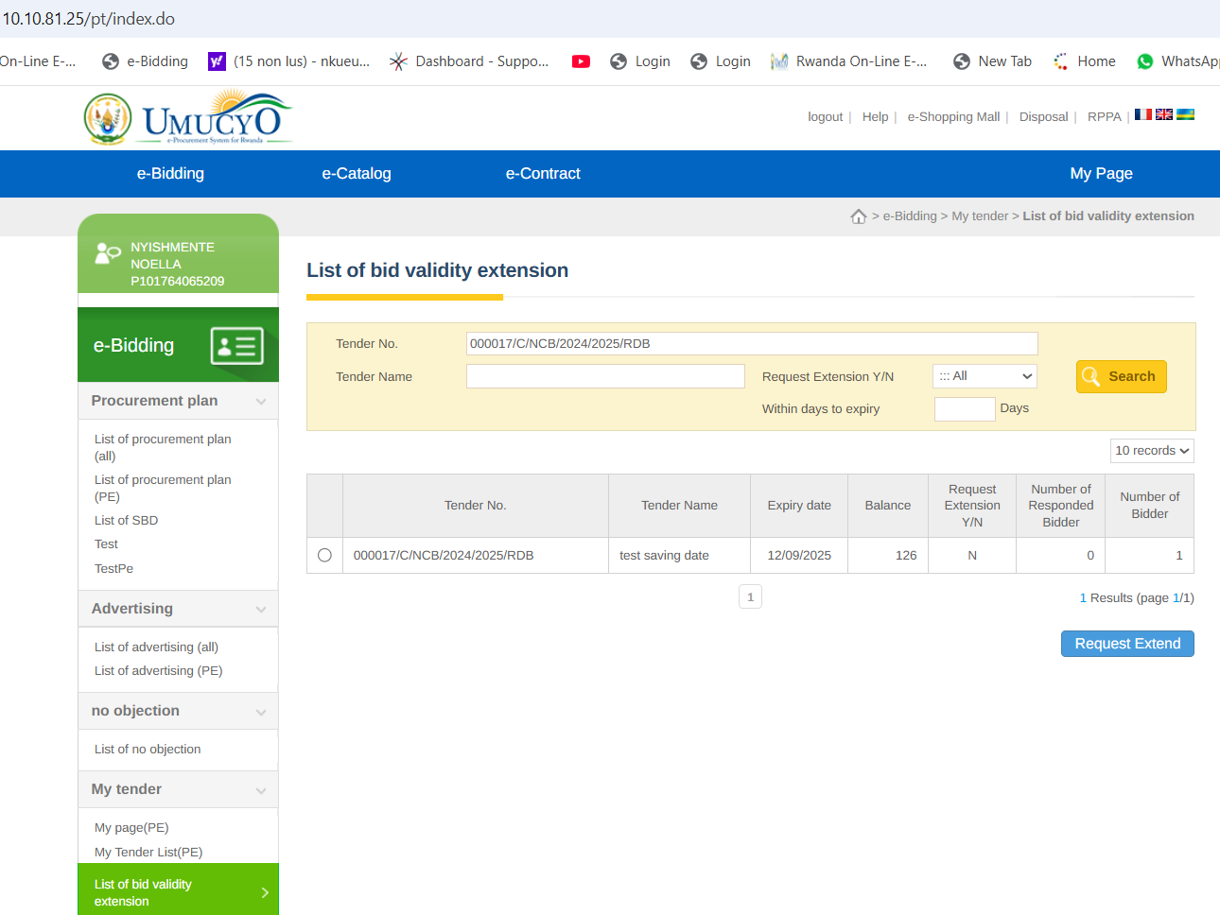

1. Tenders with status of Under evaluation **(fixed)**

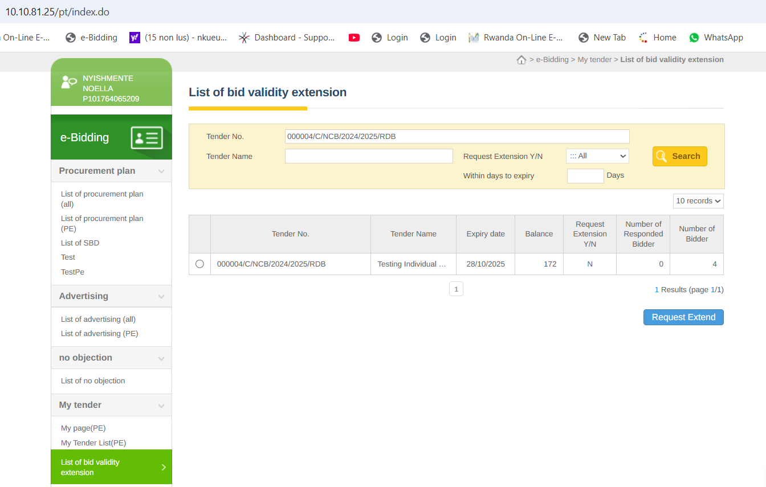

1. It is not allowed to extend above 60 days as per the law**(Fixed)**

